Football Words/Phrases

Football Terms:
Audible
Backfield
Backs
Blitz
Blocking
Bump-and-run
Eligible receiver
Encroachment
End zone
Extra point
Fair catch
Field goal
Fumble
Holding
Intentional grounding
Interception
Lateral
Line of scrimmage
Linemen
Neutral zone
Nickel defense
Offside
Pass protection
Play-action pass
Pocket
Punt
Quarterback
Receivers
Rush
Sack
Safety
Scrambling
Snap
Special teams
Tackle
Touchdown
Turnover

List of Football Teams (and city they are affiliated with)
Arizona Cardinals
Atlanta Falcons
Baltimore Ravens
Buffalo Bills
Carolina Panthers
Chicago Bears
Cincinnati Bengals
Cleveland Browns
Dallas Cowboys
Denver Broncos
Detroit Lions
Green Bay Packers
Houston Texans
Indianapolis Colts
Jacksonville Jaguars
Kansas City Chiefs
Los Angeles Chargers
Los Angeles Rams
Miami Dolphins
Minnesota Vikings
New England Patriots
New Orleans Saints
New York Giants
New York Jets
Oakland Raiders
Philadelphia Eagles
Pittsburgh Steelers
San Francisco 49ers
Seattle Seahawks
Tampa Bay Buccaneers
Tennessee Titans
Washington Redskins

Football Fill in the Blank
Arizona _____________
Atlanta _____________
Baltimore _____________
Buffalo _____________
Carolina _____________
Chicago _____________
Cincinnati _____________
Cleveland _____________
Dallas _____________
Denver _____________
Detroit _____________
Green Bay _____________
Houston _____________
Indianapolis _____________
Jacksonville _____________
Kansas City _____________
Los Angeles _____________
Los Angeles _____________
Miami _____________
Minnesota _____________
New England _____________
New Orleans _____________
New York _____________
New York _____________
Oakland _____________
Philadelphia _____________
Pittsburgh _____________
San Francisco _____________
Seattle _____________
Tampa Bay _____________
Tennessee _____________
Washington _____________

What a great pass.
Halftime show
What's the score?
Who won?
Look at him run
Quarterback and Running back
Offense and Defense
The kicker's warming up
Kick a field goal
It looks cold
It's playoff time Super Bowl
Where's the Super Bowl?
Game time
Kick off
Let's watch the game.
The fans are wild.
Fire the coach
It's halftime
4th quarter
Ist and 10
4th down
Go for 2
Punt the ball Is he hurt?
He's out for the season.
Rookie year
Sometimes I like the Broncos
Fair weather fan
Nose bleed section

Football MVPs
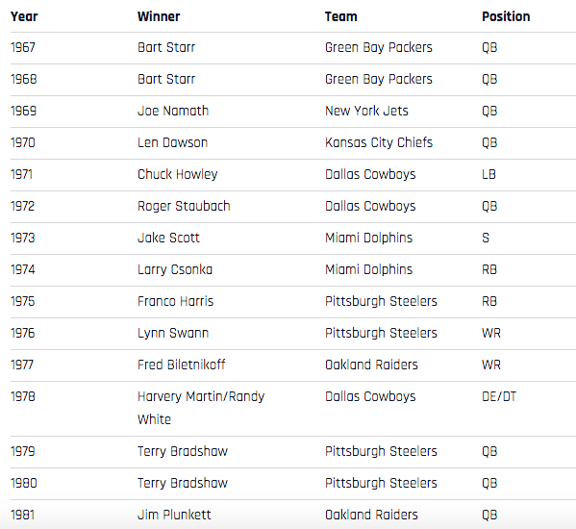
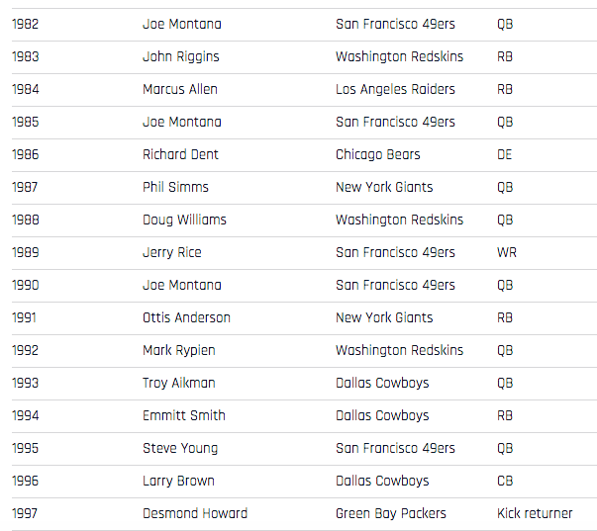
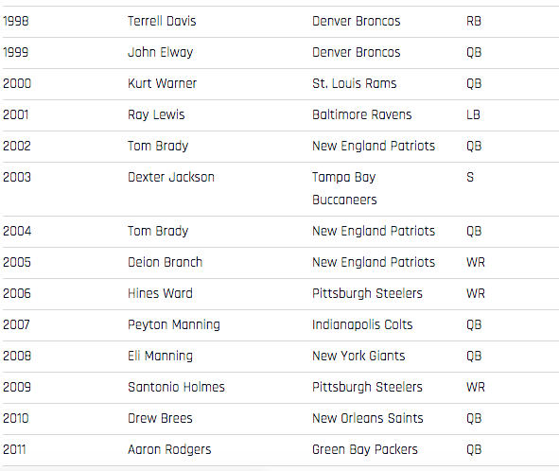

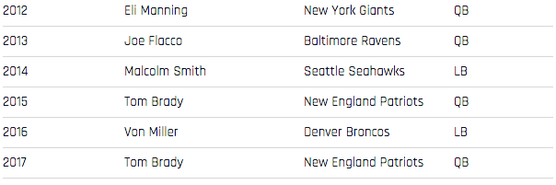
2018 Nick Foles Philadelphia Eagles QB

https://www.si.com/nfl/2018/02/02/complete-list-super-mvp-history

Kansas City Chiefs Roster
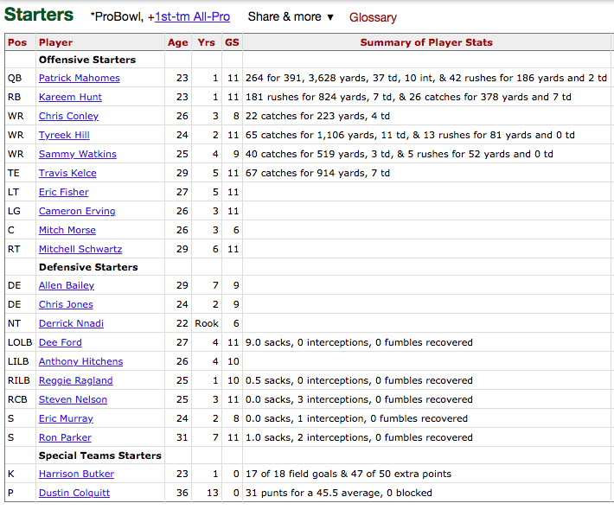

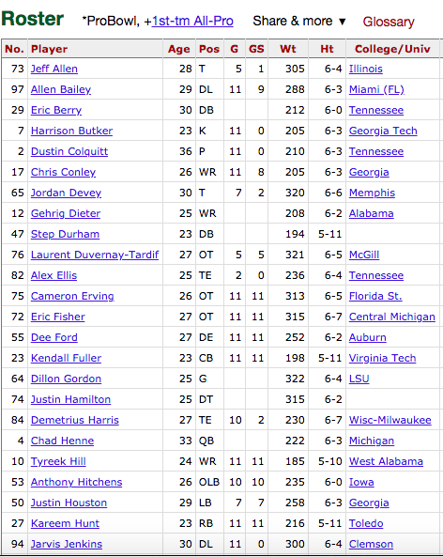

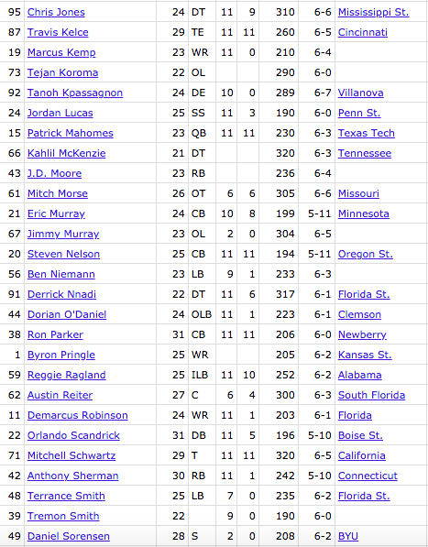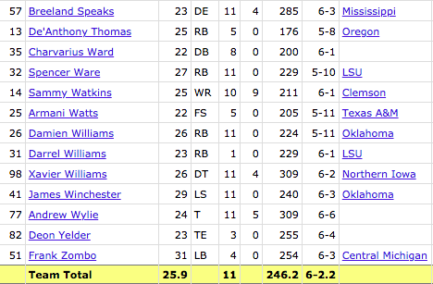

https://www.pro-football-reference.com/teams/kan/2018_roster.htm

Position Abbreviations
Abbreviation Position
QB Quarterback
RB Running Back
FB Fullback
WR Wide Receiver
TE Tight End
OL Offensive Lineman
C Center
G Guard
LG Left Guard
RG Right Guard
T Tackle
LT Left Tackle
RT Right Tackle
K Kicker
KR Kick Returner
DL Defensive Lineman
DE Defensive End
DT Defensive Tackle
NT Nose Tackle
LB Linebacker
ILB Inside Linebacker
OLB Outside Linebacker
MLB Middle Linebacker
DB Defensive Back
CB Cornerback
FS Free Safety
SS Strong Safety
S Safety
P Punter
PR Punt Returner

https://sites.google.com/site/americanfootballcourse/defense

Steelers Words
- Chunkability
- Axiom
- 11 personnel
- H-back
- Empty
- Formation
- Backfield
- RPO (run-pass option)
- Shallow cross
- Zone

Source: https://www.behindthesteelcurtain.com/2019/6/6/18653714/an-offensive-glossary-for-pittsburgh-steelers-fans-to-prepare-for-the-2019-season-randy-fichtner

Common Mike Tomlin Phrases
- Undressing blitz packages
- Thoughtfully non-rhythmic
- Division of labor
- Upward trajectory
- Let practice be our guide
- Spin the dial
- Tackling woes associated with positioning
- Bumps and bruises associated with tackle football

Source: https://www.espn.com/blog/nflnation/post/_/id/216822/steelers-coach-mike-tomlins-play-to-win-dictionary-opens-every-week

Steelers Team
- Head Coach: Mike Tomlin
- Assistant Head Coach: John Mitchell
- Offensive Coordinator: Randy Fichtner
- Defensive Coordinator: Keith Butler
- General Manager: Kevin Colbert
- Owner: The Rooney Family
- Heinz Field
- Quarterbacks: J.T. Barrett
  - Ben Roethlisberger
- Defensive lineman: Cameron Heyward
- Running back: James Conner
- Wide receiver: JuJu Smith-Schuster
- Defensive backs: Minkah Fitzpatrick
  - Joe Haden
- Offensive lineman: David DeCastro
- Linebacker: Bud Dupree
  - T.J. Watt
- Cornerback: Steven Nelson
- Tight end: Vance McDonald
- “Mean” Joe Greene, defensive lineman
- Jack Lambert, linebacker
- Mel Blount, cornerback
- Franco Harris, fullback/running back
- Terry Bradshaw, quarterback
- Jack Ham, linebacker
- Rod Woodson, defensive back
- Mike Webster, center
- Hines Ward, wide receiver
- Troy Polamalu, safety
- Ernie Stautner, defensive lineman
- John Stallworth, wide receiver
- Jerome Bettis, aka “The Bus,” running back
- Lynn Swann, wide receiver

Source: https://bleacherreport.com/articles/808794-the-25-greatest-players-in-pittsburgh-steelers-history

