Scottish Genealogy Phrases

- About 50 million people worldwide
  - Claim Scottish ancestry.
  - From Australia and New Zealand
  - Through Europe
  - To the USA and Canada.
- Thanks to the internet,
  - It’s never been easier
  - For Scots to trace
  - Their roots back
  - To the glen or village
  - Where they began.
- Scotland is a world leader
  - in providing family history information on the internet,
  - partly because written records go back a long way.
- The main examples are:
  - registers of births,
  - marriages and deaths
  - dating back to 1553,
  - Census records from 1841 to 1911,
  - and wills dating back to 1500
    - all available online
- The National Records of Scotland is responsible for the registers of:
  - births, marriages and deaths,
  - and the taking of the Census.
- These historic records are publicly available
- Since 1998, anyone can access the records
  - through the genealogical website:
  - Scotland's People.
- Around 100 million individual records are available
  - and records are added regularly.
Source: https://www.scotland.org/about-scotland/our-people/ancestry

Common Abbreviations in Genealogy:
- b. or bn.
  - Date of birth
- b. or bur.
  - Date of burial
- C.
  - Abbreviation of latin word “circa”
  - Meaning an approximate date or time
- d.
  - Date of death
- dsp
  - Abbreviation of a Latin term
  - Meaning “died without issue”
- et. al.
  - abbreviation of Latin term
  - meaning “others”
  - indicating the presence of other names
  - not listed on the document
- JP
  - Justice of the Peace
- m., m1, m2
  - Marriage date,
  - Numbers indicate first, second marriage
- n.d.
  - No date known
- ob.
  - Abbreviation for the Latin term “obit”
  - Meaning deceased
- Tutor
  - Guardian of underage person or minor
- Unm.
  - Unmarried
- Dower:
  - Share of husband’s real estate
  - To which the widow is entitled
- Estate:
  - The total property held
  - By an individual
  - And available after death
- Grantee:
  - Recipient of proper
  - either through purchase, gift, or request
- Grantor:
  - Individual who sells or gives property to another person
- Ibid:
  - Same location
  - Identifies a document
  - That has already been quoted
- Intestate:
  - Died without leaving a will
- Issue: offspring
- Nee:
  - Identifies a woman’s maiden name
- Proximo:
  - Used in dates for next
  - Usually refers to the following month
- Relict:
  - Widow of particular individual
- Sic:
  - Denotes an incorrect fact

Source: https://www.pbs.org/opb/historydetectives/technique/genealogy-glossary/

Scottish Clans Phrases
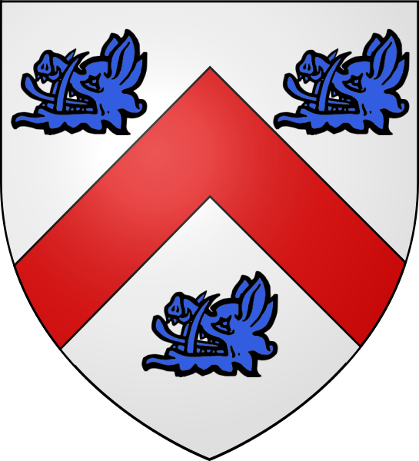

COCHRANE:
- Argent, a chevron,
- Gules, between three boars’ heads,
- erased, Azure

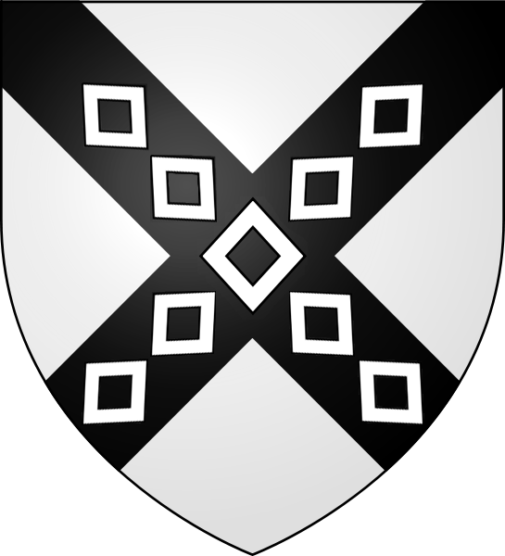

BLAIR:
- Argent, on a saltire,
- Sable, nine mascles,
- of the first
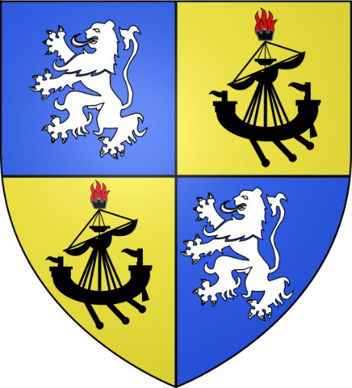

MACDOUGALL:
- Quarterly, 1st and 4th,
- Azure, a lion rampant,
- Agent (for MacDougall);
- 2nd and 3rd, Or,
- a lymphad, Sable,
- with a beacon on the topmast,
- Proper (for the Lordship of Lorn).

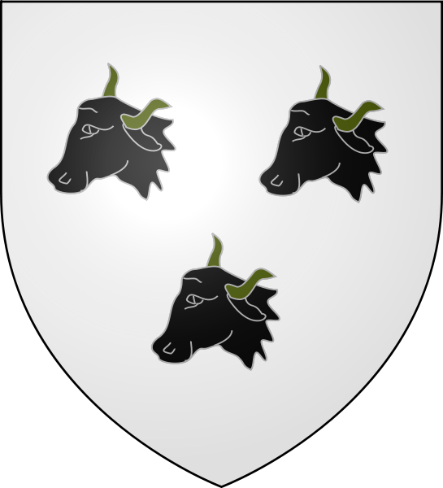

TURNBULL
- Considered a sept of Clan Douglas
- Places of interest:
  - Fatlips Castle
  - Denholm
  - Roxburghshire
  - Ruined seat of the Turnbulls of Barnhill

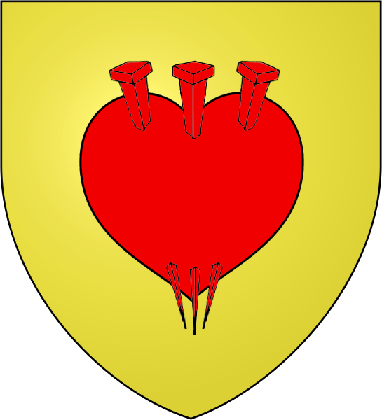

LOGAN
- Or, three piles
- (passion nails), in point
- piercing a man’s heart
- in base, Gules
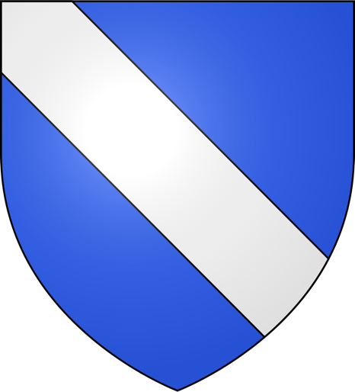
BISSET
- BISSET of Lovat
- Azure, a bend, Argent
- William the Lion brought a group of young Anglo-Normans to Scotland
- This was in 1174
  - When he returned from captivity in France and England
- He was friends with these Anglo-Normans
- One of them was one Henricus Byset
  - He is on record as having witnessed a Charter
    - (c.1198)
- John Byset is the son of Henricus
- He was granted lands in Morayshire

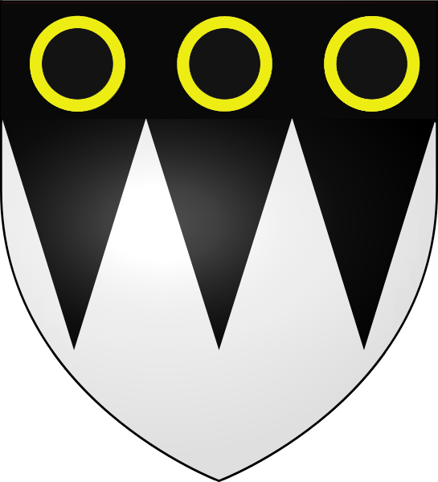
YOUNG
- Places of Interest:
- Aldbar or Auldbar Castle at Brechin,
  - (in Angus)
  - was a four-storey 16th century tower
- This was acquired by the Youngs in the 17th century
- Then demolished in 1965
- John Yong de Dyngvale witnessed a Charter
  - by the Earl of Ross in 1342
- The surname derived from being a junior
  - with a distinguished father,
  - similar to being called “Younger”

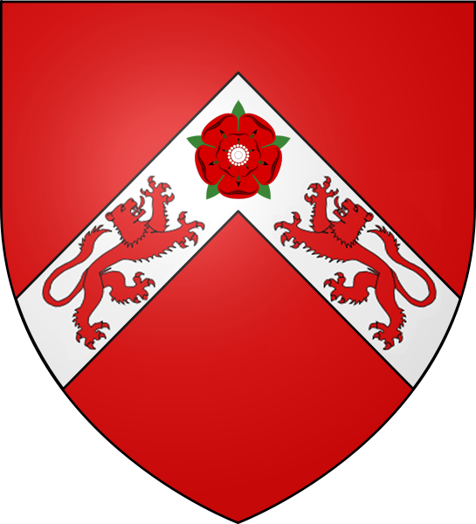

HEPBURN
- HEPBURN of Hailes
- Gules, on a chevron,
- Argent, two lions, counter-passant,
- pulling at a rose, of the first

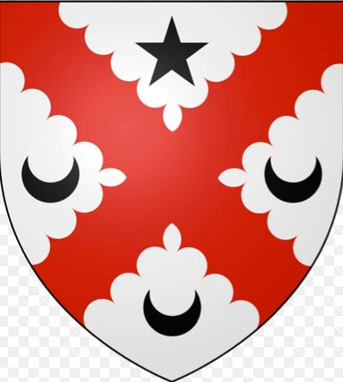

ANDERSON
- Arms of Anderson of that Ilk,
- the putative 16th century Chief of Clan Anderson,
- English: Argent a saltire engrailed Gules
- between in dexter,
- sinister and base
- three crescents and in chief a mullet Sable

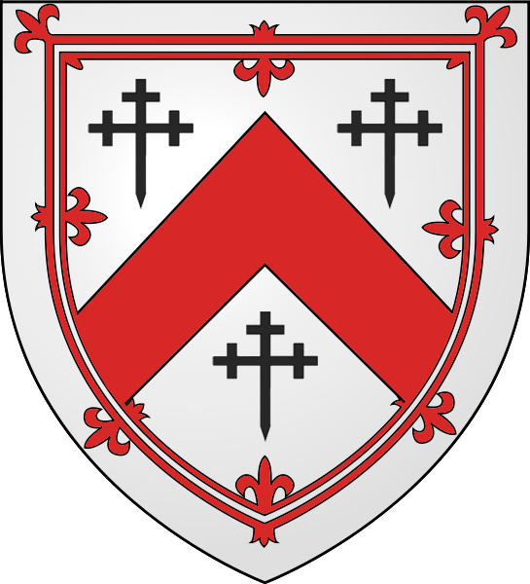

KENNEDY
- KENNEDY, Earl of Cassilis
  - and Marquess of Ailsa
- Argent, a chevron,
- Gules, between three crosses crosslet fitchée,
- Sable, all within a double tressure,
- flory counterflory,
- of the second

Source: https://www.scotclans.com/scottish-clans/clan-kennedy/kennedy-coat-of-arms/; https://www.scotsconnection.com/clan_crests/kennedy.htm

