Scottish Genealogy Sentences
The Duke of Kent

- The burning aircraft was first discovered by farmer David Morrison and his son, Hugh.
- They discovered it as they searched the Caithness countryside for their sheep on 25 August 1942.
- They had heard the sound of the engines overhead and then a muffled explosion.
- The patrol bomber hit the hillside at Eagle's Rock near Dunbeath.
- The RAF S.25 Short Sunderland Mark III flying boat had been en route to Iceland.
- It crashed near the east coast of Scotland.
- There was only one survivor – Flight Sergeant Andrew Wilson Jack, aged 24 from Grangemouth.
- The rear gunner in the aircraft, he was thrown clear when the plane hit the hillside.
- Permission to proceed with the visit to Iceland had only been granted by the King earlier in the week.
- Sitting alongside Flight-Sergeant Jack was His Royal Highness Prince George, the Duke of Kent – brother to the King.
- Prince George was known in Scotland as The Earl of St Andrews.
- He was accompanied by Lieutenant John Lowther, his secretary for seven years, and his Air Equerry, Pilot Officer the Hon. Michael Strutt.
- Flying the aircraft was Flight-Lieutenant Frank McKenzie Goyen.
- In total, there were 15 fatalities.
- The victims of the crash are recorded in the statutory register of deaths for the district of Latheron.

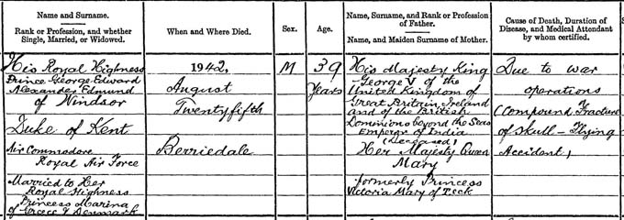

Detail from the death entry for His Royal Highness, The Duke of Kent, 25 August 1942
National Records of Scotland, Statutory Register of Deaths, Latheron, 038/58 page 20

- Since the age of 13, Prince George had served in the forces.
- First attending naval college in 1915, he rose through the ranks and was made captain in 1937.
- The same year he was also commissioned as a colonel in the British Army and in the equivalent rank of group captain in the Royal Air Force (RAF).
- The outbreak of war saw these positions rise to rear admiral in the Royal Navy, major-general in the British Army and air-vice marshal in the RAF.
- In April 1940 he renounced his honorary title in the RAF, believing that this made him senior to many other men who had greater experience.
- He became a Group Captain in the Training Command.
- He was tasked with supervising welfare work at the larger air force stations and boosting morale.

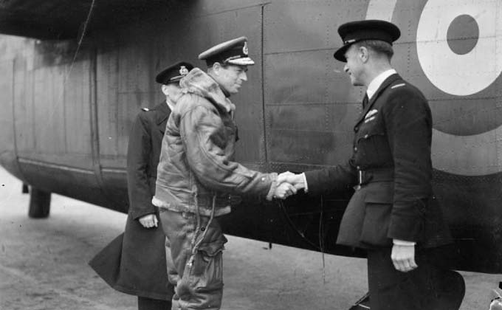
A photograph of The Duke of Kent shaking hands with the pilot of the aircraft taking him from Prestwick to Canada - the first time a member of the Royal Family crossed the Atlantic by aircraft. (Detail)
Source: Imperial War Museums, CH 3161, Royal Air Force Ferry Command, 1941-1943. Public Domain.

- Prince George was created Duke of Kent, Earl of St Andrews, and Baron Downpatrick.
- This was shortly before his marriage to Princess Marina of Greece and Denmark.
- They married at Westminster Abbey on 29 November 1934.
- They had three children: Prince Edward, Princess Alexandra and Prince Michael.
- Prince Michael was born less than two months before his father’s death. His baptism was the last official royal event that the Duke attended.
- Immediately after the crash, the Duke’s body was temporarily laid to rest with the other victims of the crash.
- It was then brought to London and buried in the Royal vault at St. George’s Chapel, Windsor.
- In August 1968, the day before his wife’s funeral, his body was transferred to The Royal Burial Ground at Frogmore.
- Princess Marina was also buried here.
- There was an inquiry and The Liverpool Echo reported its findings on 7 October 1942.
- The inquiry had found the aircraft ‘was flown on track other than that indicated in the flight plan given to the pilot.
  - ‘It was also at too low of altitude to clear rising ground on track.
  - ‘Weather encountered should have presented no difficulties to experienced pilot.
  - ‘Examination showed that the engines were under power when aircraft struck ground.’
- Despite this, various conspiracy theories spread including the belief that it was in fact the Duke who was flying the plane.
  - This theory states that it was on its way to Sweden for peace talks with Germany.
  - The captain’s flight plan and the subsequent inquiry papers were all ‘lost’.
- Whatever the reason for the crash, 15 families had lost their loved ones.
- After a short period of mourning, Princess Marina busied herself by resuming her royal duties.
- Shortly after the accident, she visited the families of the men who had died.
- She also visited the site of the crash.
- A granite cross had been erected in memoriam, both during the war and on the 10th anniversary with her three children.

Source: https://www.scotlandspeople.gov.uk/article/our-records-duke-kent

Scottish Clans Sentences
COCHRANE:
- The surname derives from the lands of Cochrane (Old Coueran).
- This is in Paisley, Renfrewshire.
- Although there is an apocryphal legend stating that:
  - The name originates from two Gaelic words meaning 'the roar of the battle.'
- Walter de Coueran witnessed a Charter in 1262.
  - It was by Dougal MacSwein to Walter Stewart, 5th Earl of Menteith.
- William de Coughram rendered homage to Edward I of England in 1296.
- Robert Cochrane (d.1482) was a favourite of James III.
- Robert Cochrane was hanged at Lauder Bridge by jealous noblemen.
  - They were led by Archibald, Earl of Angus.
  - Archibald was known thereafter as 'Bell-the-Cat.'
- In the early 17th century, William Cochran of that Ilk died without a male heir.
- The Chiefship passed through the female line to his grandson: Alexander Cochrane.
- He took the name and coat-of-arms of Cochrane.
- Alexander Cochrane, was a supporter of Charles I.
- He became ambassador to Poland for the exiled Charles II.

BLAIR:
- The Blair surname comes from the Gaelic word, "Blar."
- This means field or plain.
- Blair as a place name element is found in over two hundred instances throughout Scotland.
- Blairduff and Blairmore in Aberdeenshire are two examples.
- Blair as a surname in Scotland is first recorded in the early 1200's.
- There were two principal Blair families in Scotland:
  - Blair of Blair from Ayrshire, and
  - Blair of Balthayock from Perthshire
- There is no evidence to suggest that the two families shared a common ancestor.
- Alexander de Blare witnessed an agreement between the burgh of Irvine and Brice de Eglunstone in 1205.
- Alexander was probably of the Barony of Blair in Ayrshire.
- This was granted by King William "the Lion" in the 12th century.

MACDOUGALL:
- During the early stages of the Scottish Wars of Independence, the MacDougalls fought on the Scottish side
  - (Like their close kinsfolk the Comyns).
- However, Robert the Bruce and his men killed John of Lorn's cousin,
  - (the Red Comyn) in the Church of the Greyfriars in Dumfries in 1306.
- Then the MacDougall Chief sided with the English.
- This was not because they were anti-Scottish, but because they were anti-Bruce.
- There then ensued a tragic inter-family conflict.
- Alexander, the 4th Chief of MacDougall, and his son, John of Lorn, opposed Bruce.
- Meanwhile Duncan, Alexander's younger brother, together with a following of MacDougall men fought for Robert the Bruce.
- However, at one stage, Bruce was almost captured by John of Lorn's men.
- One of the great treasures still held by the MacDougall family is the Brooch of Lorn.
- This was allegedly torn from Bruce's cloak as he struggled to escape.

TURNBULL
- William of Rule is a Borders man.
- In the 14th century, he saved the life of Robert the Bruce when he was attacked by a wounded bull.
- He was well rewarded and thereafter was known as Turnbull.
- The Rule Water was the home of the Turnbulls.
- This place was a baronial possession of the House of Douglas.
- This was often in conflict with the ruling House of Stewart.
- By 1510, the Turnbulls had become very resistant to the authority of James IV.
- James IV decided to make an example of the Turnbulls.
- 200 members of the family were summoned to appear before him.
  - They wore linen sheets, swords in hands and halters around their necks.
  - Some were hanged and others imprisoned.
- In the following century, the unsettled character of the Borders continued.
- This caused James VI to instruct his Wardens to use 'hostile feud in hostile manner against all malefators.'
- A large scale dispersal began at this time.
  - Especially after the Chiefly branches of Bedrule and Minto became financially broken.
- Quantities of clansmen sailed to the Carolinas, Nova Scotia and Newfoundland.

LOGAN
- Two distinct branches of this Family exist.
  - There is one Highland, usually taking the name MacLennan.
  - The other, Lowland, descends from Sir Robert Logan of Restalrig.
    - He married a daughter of Robert II.
- Then in 1400, Sir Robert Logan became Admiral of Scotland.
- Over a century earlier, several people (listed below) had rendered homage to Edward I of England in 1296.
- These people were Philippe de Logyn, Burgess of Montrose, and Thurbrand de Logyn of Dumfriesshire.
- However, the surname of Logan is thought to have derived from the place name Logan in Ayrshire.
- In 1329, several Scottish nobles set off on a pilgrimage to the Holy Land with the heart of Robert the Bruce.
- Sir Robert and Sir Walter Logan were among these nobles.
- At the Battle of Teba, they fought against the Moors in Andalucía in Spain.
- They were both killed.

Source: https://www.scotsconnection.com/clan_crests/clan-crest-viewer-abercrombie-to-erskine.htm

